**Montclair State University**

**Check Point 1 Document - Final Project**

**By MSU Developers - Team Circuit**

Course: CSIT-337-01 Internet Computing

Instructor: Professor John Jenq

Date: December 12 2023

**Team Members of MSU Developers(Circuit)**

Leader/Programmer - Xavier Warner

Assistant/Programmer - Dhruv Rana

Editor/Programmer - Harrison Lessne

Editor/Programmer - Damon Wich

**Check Point 1**

* **Team Name:** Circuit
  + **Team members:**
    - Leader/Programmer - Xavier Warner
    - Assistant/Programmer - Dhruv Rana
    - Editor/Programmer - Harrison Lessner
    - Editor/Programmer - Damon Wich
* **Name of Website:** TheCircuit
* **Purpose, Motivation, and description of our website:**
  + The purpose of this website is to make a website that allows users to buy and sell their owned PC Parts. This is similar to the Facebook marketplace but instead of selling and buying anything there, we are only selling and buying computer parts.
  + The motivation behind this website is that computer parts have skyrocketed in price over the years due to scalpers or just unfair prices from high-up companies. So team Circuit has decided to make an online e-store specifically tuned to computer parts so customers can shop online.
  + Our website is an e-store to allow customers to do online shopping. Although this e-store is specifically tailored to selling and buying computer parts. High-up companies do not sell these computer parts, but instead, they are sold by users themselves.
* **Meeting Plan:** 
  + Our meeting plan will consist of having weekly meetings that last for 4 hours. Specifically, these meetings will be on Mondays, Wednesdays, and Saturdays. Also, these meetings are online using Discord to communicate and share our progress on the project itself. Down Below is a detailed breakdown of our meeting times.
    - Mondays: 4 pm - 8 pm
    - Wednesday: 12 pm - 4 pm
    - Saturdays: 10 am - 2 pm:
* **Draft Layout of Website - Site Map:**

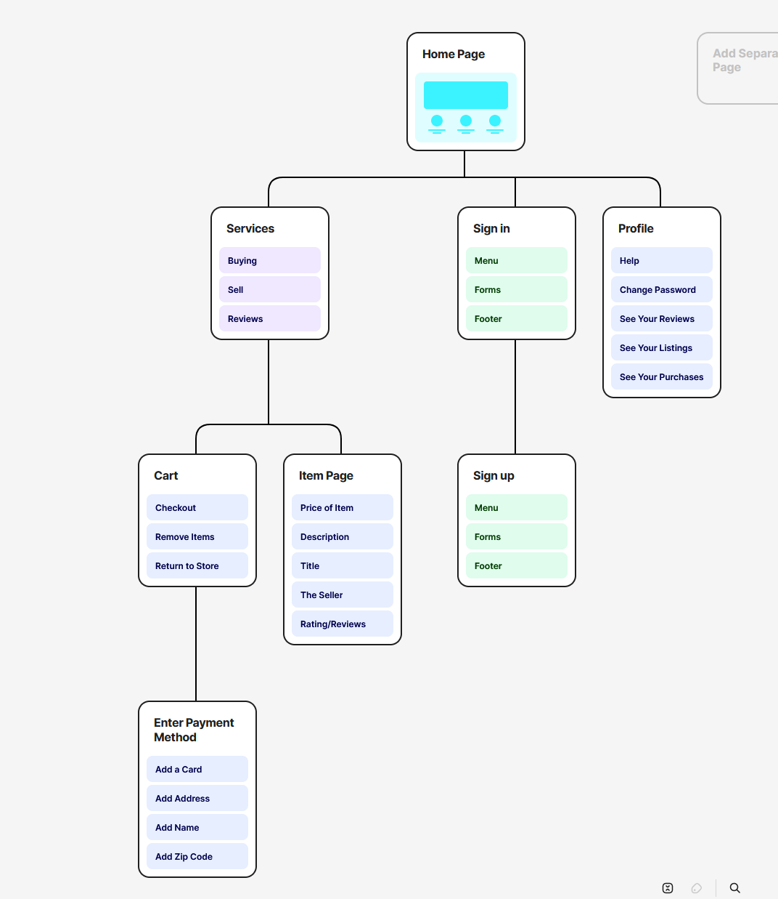

* **Description of Front Pages:**
  + Login Page:
    - This page allows the user to login to our website with a username and password, giving them access to our website.
  + Create Account Page:
    - This page allows new users to sign up to our website so that they can access our website. This requires you to input:
      * The username must be 5 to 10 characters long and only accepts numeric and alphabetical characters.
      * The password must be 8 to 10 characters long and only accepts numeric and alphabetical characters.
  + **Home page:**
    - This is the main hub for our website. This page has multiple functions and sub-pages that are described below:
      * Search Function:
        + This function allows the user to search for specific items on the homepage that match the words that they inputted. For example, if the user inputs “ball” then only related items to the word ball will show up
      * Item Function:
        + This Function shows items(images) to the user that when the user clicks on a specific item, it will give the user a detailed view of the item with information such as item name, seller, price, description, feature, buy button, and more.
    - **Add Items to Sell Page:**
      * The is page is a form where the user can add an item to the website’s database. The user will input information such as an item image, name, description, features, and price. Submitting the form will add the item to the website.
    - **Profile Page:**
      * This page allows the user to see their username and allows the user to change their password, through a change password feature. Also, this page allows the user to see the items that they have put up on the website and the purchases they have made.
    - **Cart Page:** 
      * This page shows the user which items they want to buy allowing them to remove items if necessary and also check out items as well.
      * Remove Items Function:
        + This function allows the user to remove any item they have added to their cart before checkout.
      * Check Out:
        + Purchase Forum:

This is where the user inputs their payment and credit card information, and then by clicking check out, they purchase the items in their cart.

* + - * + **Thank You Page:**

Thanks the user for their purchase.

* **Views -**
  + There are two main views: the user view and the admin view.
  + User view:
    - Create an account
    - Sign-in
    - Profile
    - Add items to sell
    - Remove only items they have added
    - Buy items
    - View item details
    - Add item to cart
    - View cart
    - Purchase items
      * Enter payment details
  + Admin view:
    - Sign-in
    - Remove any item on the website
    - Ban/Suspend users
    - View item details
  + Banned User View:
    - Can not sign-in
* **Wireframes:**
  + Login Page:

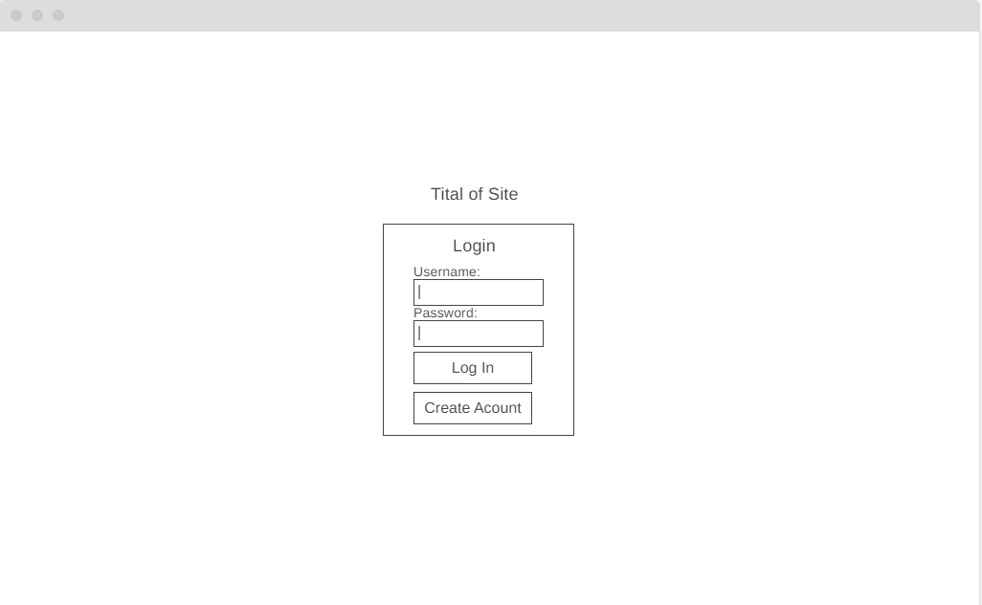

* + Create Account Page:

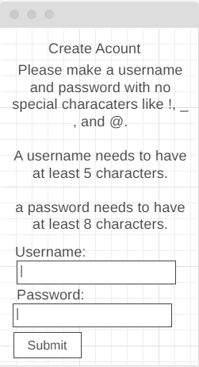

* + Home page:

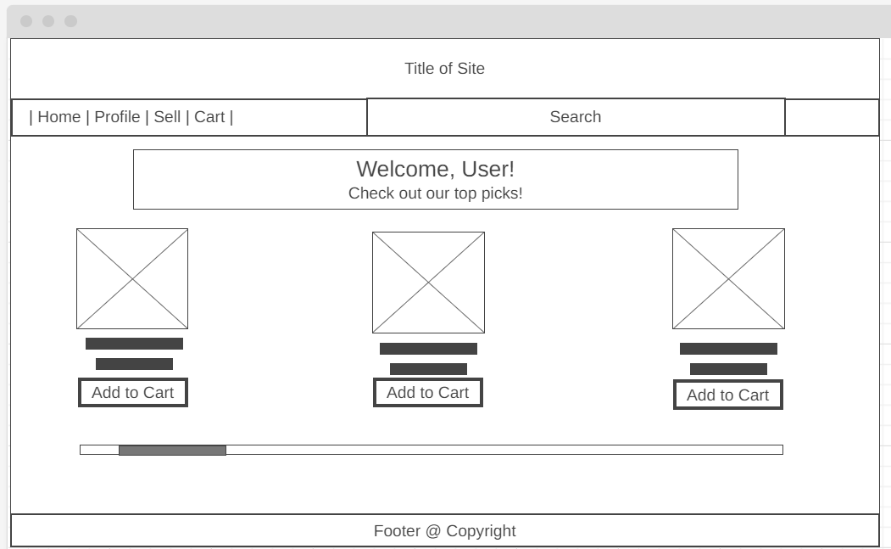

* + Clicking on Item - Item View:

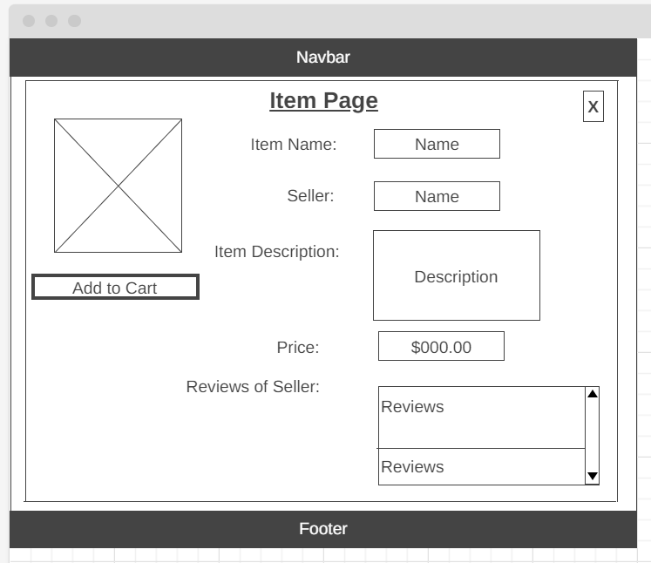

* + Add Items to Sell Page:

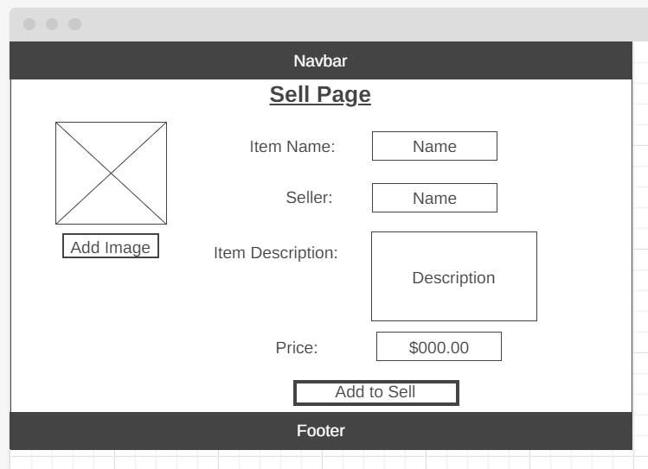

* + Profile Page:

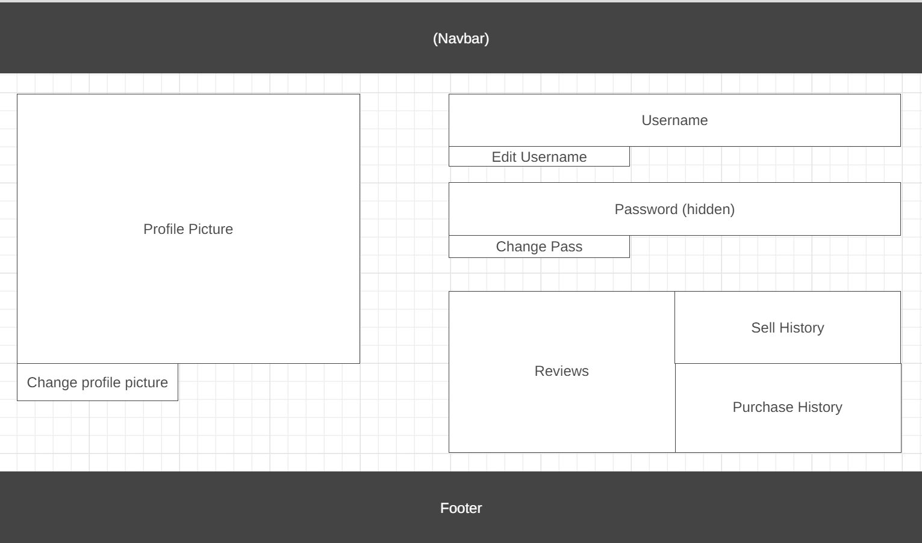

* + Cart Page:

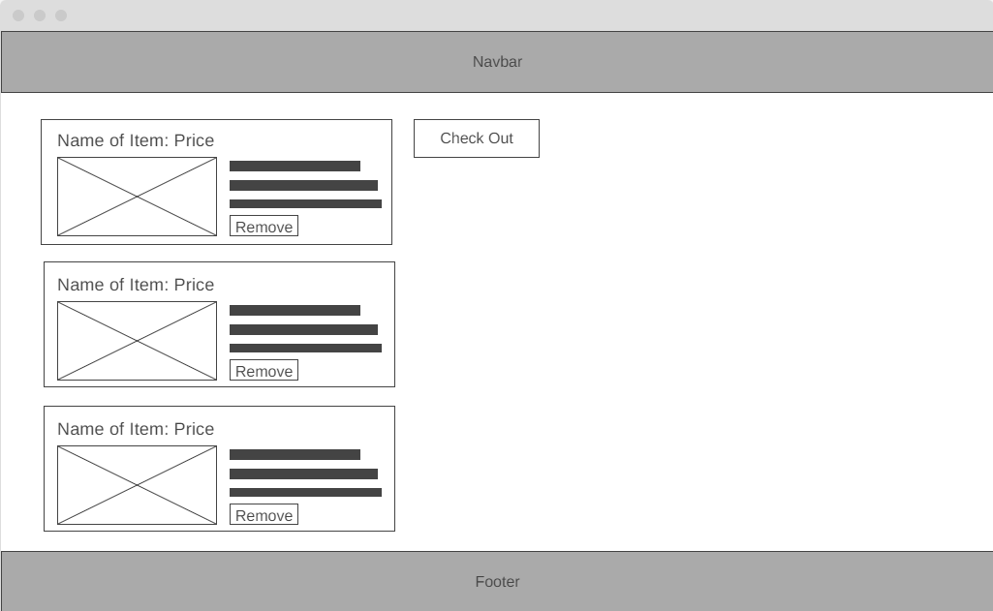

* + Check Out Page:

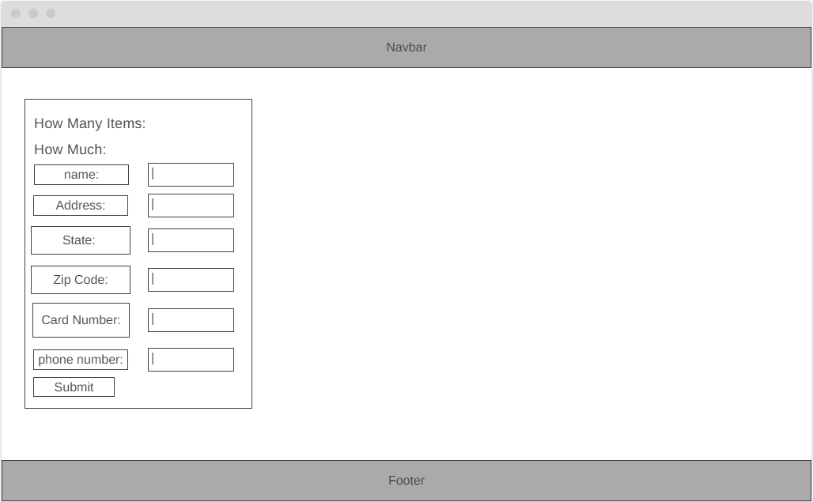

* + Thank You Page:

